EE093IU

DIGITAL SIGNAL PROCESSING LAB

Lab 1

Introduction to DSP Laboratory

Full name: Nguyen Minh Duc

Student number: ITITIU21045

Class: EE093IU Group 03

Date: February 28, 2023

# OBJECTIVES

In this laboratory, you will be introduced:

1. Lab policies.
2. The theory of DSP

Lab Reports and Grading

Students are required to turn in a Pre-Lab report before each lab session, and a Lab Report per experiment. The Pre-Lab report includes the calculation and simulation parts. *You are not allowed to do the lab without your Pre-Lab report.* The due date for each Lab Report is posted in the class schedule above.

Each lab report is 100 points that will be distributed as follows:

Pre-lab: 30 points.

Lab report: 70 points.

As shown above, 30% of the lab's final grade is deducted if the student fails to complete the pre-labs. 70% of the lab's final grade is based on your lab operation and the written post-lab report. Even though you are working in teamwork, *you have to turn in your lab report individually with your own calculation and explanation*. When applicable, late reports have a 10% grade deduction per delayed day. The final grade is the average of all the graded items in the course.

1. Lab Policies
   1. ***Important Notes: Read carefully the following points:***

* The students should be prepared on the theoretical material of the lab topic.
* Be prepared to answer questions.
* Prepare previously all Pre-Lab calculation and simulation to avoid a 30% deduction from the lab report grade.
* There is no make-up lab. Not attending a lab implies that the student has no grade for that lab.
* The presentation of a previous year's or someone else's lab is considered cheating.
* The penalty for cheating on any graded item is an automatic zero in the course.
  1. ***Instruments and supplies***, the major instruments you will need are permanently installed in the stations.
  2. ***Leave your workplace at least as clean and tidy as you found it***. Put everything back in its proper place. If the workplace is not tidy after you finish, it will cause to lose some points.
  3. ***No foods or drinks are allowed inside the lab for any reason*.**

# PRE-LAB

Complete this pre-lab on your own and bring a copy of this with you to lab-section.

Answer the following questions:

* 1. What is signal? How many types of signals and explain?
  2. How the analog signal be processed? Why we need DSP?
  3. What are the advantages of DSP over analog signal processing (ASP)?
  4. What are the applications of DSP?
  5. How to remove Echo sound? Explain!

# LAB PROCEDURES

Procedure I:

* 1. Provide some example Octave codes of Variables, Matrix, array, scalar, vector, dot operations, array transposition, if-elseif-else structure, and Functions. When are dot operations used?

Variables:

>> a = 3

a = 3

Matrix:

>> A = [5 4 -3; 7 -6 4; 9 1 3]

A =

5 4 -3

7 -6 4

9 1 3

Array:

>> b = [5 3]

b =

5 3

Scalar:

>> B = [4;]

B = 4

Vector:

>> V = [5 4 -3 7 -6 4 9 1 3]

V =

5 4 -3 7 -6 4 9 1 3

Dot Operations:

>> A.*A

ans =

25 16 9

49 36 16

81 1 9

Array Transition:

>> A'

ans =

5 7 9

4 -6 1

-3 4 3

If – elseif – else:

>> age = 14;

>> if (age<12),

disp('You are under 12');

elseif (age < 18),

disp('You are a teen.');

else

disp('You are above 18.')

end

You are a teen.

Function:

function sum = sum2n(n)

sum = n*(n+1)/2;

endfunction;

>> sum2n(3)

ans = 6

Dot operations are used to perform element-wise operations on arrays and matrices.

1. Plot the function sin(2π t).

>> t = -10:0.1:10; # Value of t is from -10 to 10 with the increment of 0.1

>> plot(t, sin(2*pi*t)) # Plot the sin(2πt) graph with value of t as above

Procedure II:

1. Consider the following sum of sinusoidal functions



Using Octave to generate samples of x(t) at time instances 0:0.01:1?

>> t = 0:0.01:1;

>> x = sin(2*pi*t)+sin(6*pi*t)/3+sin(10*pi*t)/5

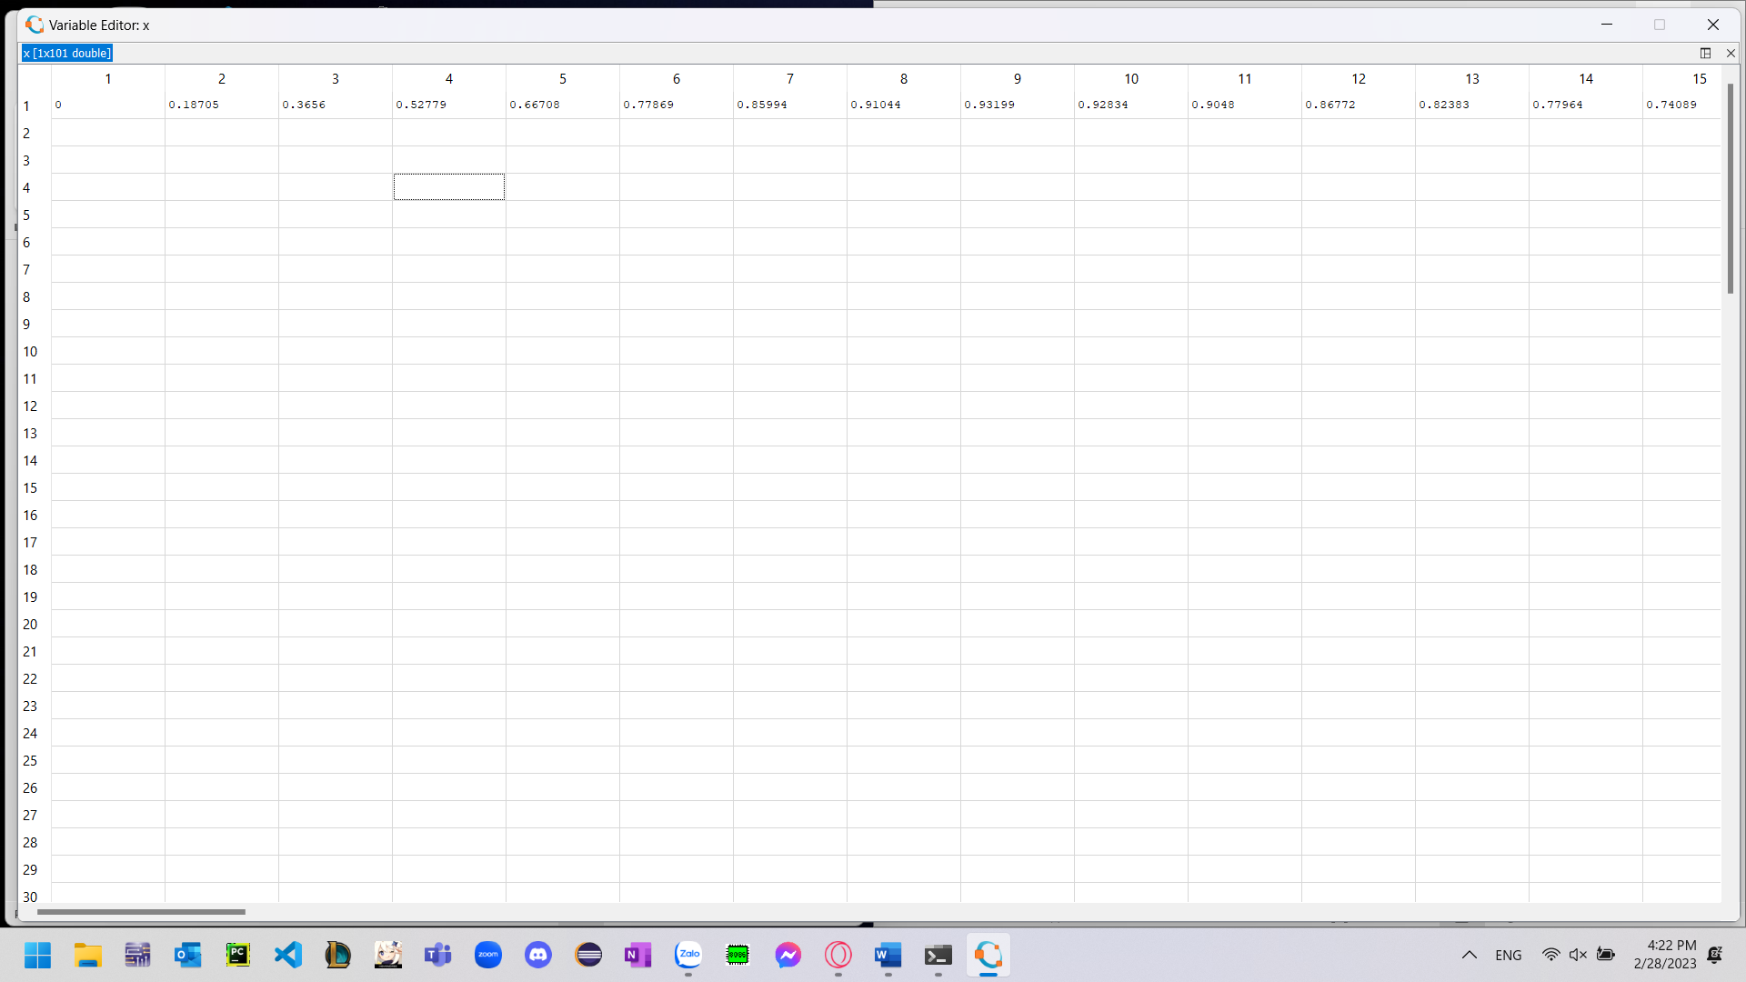

2. Consider the following function:



Implement this function in Octave and save as m-file sinsum.m

function [xt] = ques2(t,K)

xt = 0;

for i = 1:K,

xt += (1/i).*sin(2*pi*i.*t);

endfor

endfunction

3. Plot two function in 1 and 2.



